How-to: connecting grant funding in USA Spending and Federal RePORTER
Sean Pietrowicz, Alyssa Fowers, Samantha Cohen, Joel Thurston, Stephanie Shipp

Federal grant funding data has become increasingly transparent and available to the public. However, federal agencies (and divisions within the same agency) format their data differently, making cross-agency comparisons difficult. But each database usually contains unique information which would be useful to combine into one ultimate source. How can these data sources be combined? This brief outlines an attempt to combine two such databases and the challenges faced.
Spotlight on Data Sources
We identified 11 public federal funding databases, most of which focus only on a single agency (see Table 1). We put our initial focus on two databases, Federal RePORTER and USA Spending, based on their wide coverage of six major funding sources of science and engineering spending: the Department of Energy (DOE), Department of Defense (DOD), National Science Foundation (NSF), National Institutes for Health (NIH), National Aeronautics and Space Administration (NASA), and Department of Agriculture (USDA).
Source | DOE | DOD | NASA | NIH | NSF | USDA
Federal Reporter |  | ✓ | ✓ | ✓ | ✓ | ✓
USA Spending | ✓ | ✓ | ✓ | ✓ | ✓ | ✓
Current Research Information System |  |  |  |  |  | ✓
Conservation Innovation Grants project list |  |  |  |  |  | ✓
NIH Project Exporter |  |  |  | ✓
Conservation Innovation Grants All Project List |  |  |  |  |  | ✓
NSF Award Search |  |  |  |  | ✓
Office of Science Awards | ✓
DOE Public Access Gateway for Energy & Science (PAGES) | ✓
ARPA-E Projects | ✓
CDMRP Awards Search |  | ✓
NOTE: "yes" only indicates that there are at least some data from the department in the data source, not that the data are complete
Table 1: Break down of coverage of six major federal agency for the eleven identified data sources.

USA Spending (usaspending.gov) is the unified source for federal spending data in the United States, including both grants and contracts. The database has been maintained by the Treasury Department since 2008. Data are recorded at the transaction level: that is, individual amounts at the time that the transaction occurs, in addition to the overall project totals. USA Spending is particularly appealing because it has a publicly available data dictionary, unlike other databases we evaluated. USA Spending outlines a number of variables, including:
- Assistance type code: The type of assistance provided by the award.
- Business funds indicator code: The Business Funds Indicator (BFI), indicating the award's applicability to the Recovery Act.
- Business types: A collection of indicators of different types of recipients based on socio-economic status and organization / business areas.
- CFDA number: The number assigned to a Federal area of work in the Catalog of Federal Domestic Assistance (CFDA). Identifies the department and specific assistance program. The CFDA handbook specifies a rich variety of information about each CFDA code.
- DUNS: The unique identification number for an awardee or recipient. A 9-digit number assigned by Dun and Bradstreet (D&B) referred to as the DUNS® number. Note that in our analyses, a DUNS number would often vary on the same URI (see below).
- FAIN: The Federal Award Identification Number (FAIN) is the unique ID within the Federal agency for each (non-aggregate) financial assistance award.
- Record type: Code indicating aggregation status.
- SAI number: A number assigned by state review agencies to the award during the grant application process.
- URI: Unique Record Identifier. An agency-defined identifier that (when provided) is unique for every reported action.

Federal Reporter (https://federalreporter.nih.gov/) is run by the NIH. Unlike USA Spending, Federal Reporter only contains grant funding of research and development projects (R&D), excluding contracts and non R&D grants. Data from projects reaching back to 2000 exist in the database, but entries for each agency of interest become complete in 2014. Federal Reporter also lacks funding by the DOE but does cover other agencies like Health and Human Services, the Environmental Protection Agency, and Veteran Affairs. Federal Reporter reports grants at the project level; that is, the total amount of money awarded in a grant for a particular project, regardless of what period it was dispersed. Federal Reporter, unlike USA Spending, includes project terms based on the title and abstract information, as well as match scores indicating the similarity of two projects
Combining Project-Level Data in USA Spending and Federal Reporter.
Our goal was to merge databases with different fields together into a central, comprehensive database of project-level data. By merging the two, this aggregated source would include:
  - Institutional affiliations
  - Project terms (I.e. keywords)
  - All allocated payments to date
  - The total amount of the award
  - Amounts and dates of specific transactions
  - R&D status (if the grant is in Federal Reporter)
  - Descriptions of areas of work (via CFDA code)
However, creating this dataset is not straightforward, because within USA Spending, project identifiers are structured differently between agencies and even sub-agencies. The same project could appear labeled differently in Federal Reporter versus USA Spending. To link these two databases together, we examined how each of these unique project identifiers were structured and found ways to link most of these agencies together. The exact mapping is shown in Table 2 below; the conversion process by agency or subagency for USA Spending is found in Figure 1; for Federal Reporter, see Figure 2.
Within the DOD, most Federal RePORTER grants were related to one subagency: the Congressionally Directed Medical Research Programs. The DOE was not found in Federal RePORTER at all. Within the USDA, we were unable to find clear project identifier mappings for two subagencies: the Forest Service and the Agricultural Research Service.

In addition to connecting the two databases, project identifiers often contained additional information about projects. When possible, these are included in Table 2.
Figure 1: Diagram of how project identifiers were standardized across Federal Reporter.
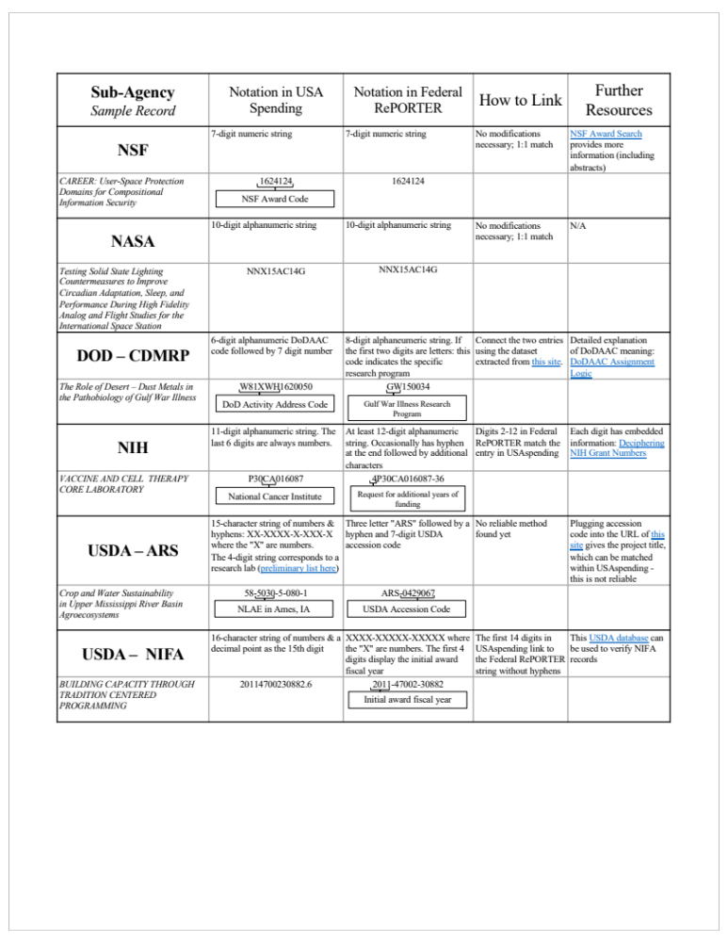 Table 2: Mapping of project identifiers between Federal Reporter and USA Spending.

Overlapping projects
With common identifiers, we can link projects found in both USA Spending and Federal Reporter. However, identifiers are not enough: the data are reported at different timescales. Federal Reporter reports overall project awards at the time when they are awarded, while USA Spending reports individual disbursements of those funds. A grant disbursed over multiple years would have only one record in Federal RePORTER, but would appear multiple times in USA Spending. Consider a grant awarded in 2012, with payments in FY13, 14, and 15. The project ID would appear in USA Spending in 2013, 2014, and 2015. In Federal Reporter, the project would appear only in FY 2012.
Thus, to gather all the additional data found in FedReporter to our data in USA Spending, we would need to acquire all Federal Reporter records prior to and including our comparison year in USA Spending. We found USA Spending projects that were originally awarded prior to Federal Reporter’s range of projects (through the form of CFDA codes no longer in common use), suggesting this approach may be limited in success. Instead, we can see which R&D project awards from Federal Reporter granted in the preceding years are present within USA Spending.
Comparing the mapped IDs in USA Spending in 2016, and Federal Reporter from 2014-2016, 60% of standardized project IDs in Federal Reporter were also found in USA Spending (Table 3).
 | Percent of Federal RePORTER projects (2014-2016) found in USA Spending (2016) | Percent of USA Spending (2016) projects found in Federal RePORTER (2014-2016)
DOD | 29% | 7%
DOE | N/A | N/A
NASA | 82% | 59%
NIH | 65% | 99.7%
NSF | 47% | 85%
USDA | 16% | 28%
Table 3: Match rate by department
Conclusion
In this brief, we’ve outlined how a citizen scientist can use existing federal funding databases to create a more comprehensive understanding of grants funded by the federal government. We provide both the protocol for combining two widespread databases, USA Spending and Federal Reporter, as well as outlined the additional information that can be gleaned from each—if you know what you’re looking for.

